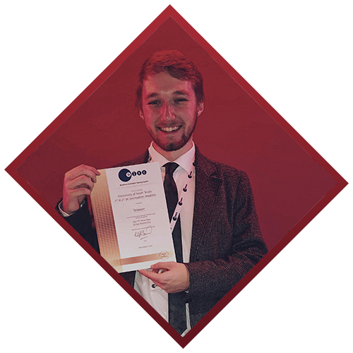 |  | Achievements
Graduated with a 1st Class (BA) in Journalism at the University of South Wales.

Multi BJTC award winning student Journalist
November 2019 and November 2020.
Part of the team that won ‘Best TV Newsday’ at the 2019 BJTC awards and ‘Best Virtual TV Newsday’ at the 2020 awards.

Runner up in ‘Best Radio Documentary’ category in 2020 awards.

Community Radio Award winning journalist
December 2020
Part of the team at Bro Radio that won ‘Station of the Year’ at the Community Radio Awards 2020, also runners-up in ‘Election Coverage’

Dan Moffat  Journalist  I am currently a journalist with BBC Radio Wales News, where I play a key role in producing Radio Wales Breakfast and Drive, and more recently becoming a member of the on-air news reading team.  In my past role, as a newsreader, presenter, and producer at Bro Radio in The Vale of Glamorgan, I helped the station in its recent recognition at the Community Radio Awards – where the station won ‘Station of the Year’ and was also nominated for best news programme and best election coverage.  I can drive, I have my own Mojo broadcast kit, and have great experience using social media to tell stories.  CONTACT  M: 07493025232  W:https://danmoffat1998.wixsite.com/danmoffat  E: Danmoff1998@gmail.com |  | Media Experience
Journalist - Bro Radio
January 2019 – September 2021
Producing/Presenting news bulletins and special news programme ‘The Vale This Week’. Researcher and write for online site too.
Part of the Election team – hosted live hustings events and reported on the 2019 General Election and 2021 Senedd Elections

Work Experience – Reporter - Global
February 2019
Covered Brexit/Six Nations/Welsh Assembly and more, recording interviews on all, and writing scripts for the Nightly News (18:45)

Work Experience + Freelance Work – BBC Wales
June 2019 + November/December 2019
Shadowing reporters and live tweeting from OBs
A researcher for the election, helping with programme run throughs

Freelance – Sky News
December 2019
A results stringer for Sky in Islwyn, reporting results but also interviewing candidates and live tweeting on social media.

Freelance – Q Radio
June 2020 – August 2020
Writing online content and helping to put together news bulletins, also recording some voice pieces on stories (available on website)

Staff – BBC Radio Wales
August 2020-ongoing
Researching and Producing the BBC Radio Wales Breakfast and Drive programmes.
Newsreading on Breakfast and Drive and on weekends.

